**NAME: ALI GHULAM MURTAZA**

**ROLL NO: BIT-24S-038**

**LAB NO: 7**

TASK N0 1: Write a function that takes two numbers and returns their product.

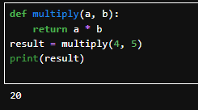

TASK NO 2:Write a function that checks whether a number is even or odd.

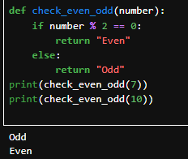

TASK NO 3: Write a function that takes a name and age and prints a greeting.

